Grupar e sumarizar campos no ALV.

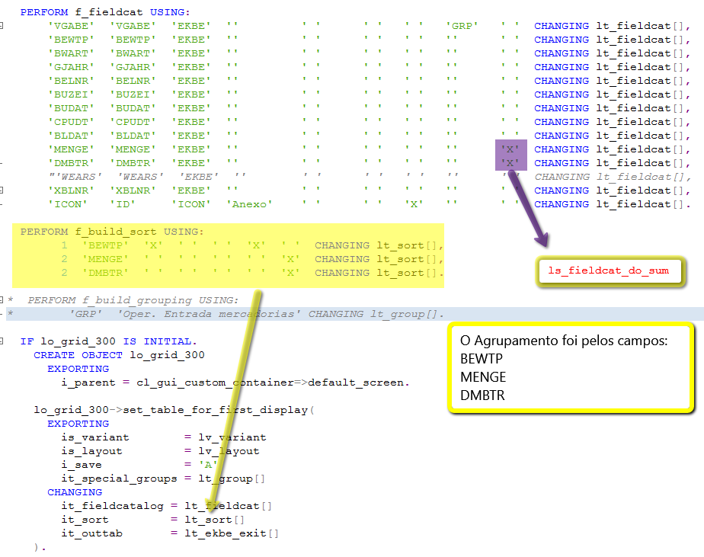

Tabela de Agrupamento:

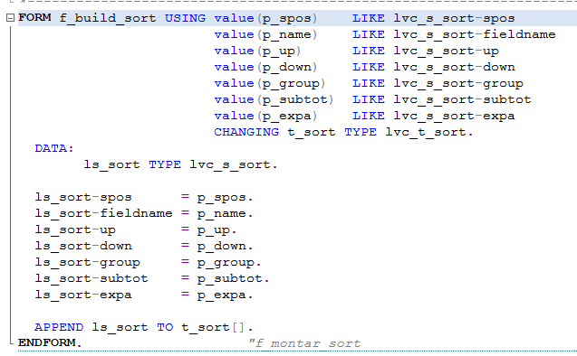

FORM f_build_sort USING value(p_spos)    LIKE lvc_s_sort-spos  
                        value(p_name)    LIKE lvc_s_sort-fieldname  
                        value(p_up)      LIKE lvc_s_sort-up  
                        value(p_down)    LIKE lvc_s_sort-down  
                        value(p_group)   LIKE lvc_s_sort-group  
                        value(p_subtot)  LIKE lvc_s_sort-subtot  
                        value(p_expa)    LIKE lvc_s_sort-expa  
                        CHANGING t_sort TYPE lvc_t_sort.  
  DATA:  
        ls_sort TYPE lvc_s_sort.  
  
  ls_sort-spos      = p_spos.  
  ls_sort-fieldname = p_name.  
  ls_sort-up        = p_up.  
  ls_sort-down      = p_down.  
  ls_sort-group     = p_group.  
  ls_sort-subtot    = p_subtot.  
  ls_sort-expa      = p_expa.  
  
  APPEND ls_sort TO t_sort[].  
ENDFORM.                    "f_montar_sor

Para sumarizar basta adicionarmos o atributo DO_SUM do fieladcat e marcarmos a linha com X como segue na figura 1.